COM4012M– Lab Week 4: JavaScript

Javascript – Part 1

Using Javascript to write HTML

Using Brackets, notepad++, HTML Kit or whichever editor you prefer working in, type in the following: -
<!DOCTYPE html>
<html>
<head><title>My first JavaScript page</title>
<meta charset="UTF-8">
</head>
<body>
<script type = "text/JavaScript">

document.write('This is my first JavaScript Page');

</script>
</body>
</html>
Save this file as javascript1.html.
Test by opening in your browser, open the file you have just written. You should get this: -
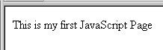

Note that I have written the JavaScript code is written inside the <body> section of the HTML between these two tags:
<script language = "JavaScript">
and
</script>
(JavaScript may also be written in the <head> section of an HTML document, but I prefer to place simple Javascript in the body where possible as it means pages load faster.)
This line is the JavaScript statement which displays some text on the page:
document.write('This is my first JavaScript Page');

Change the line to read:
document.write('<h1>This is my first JavaScript Page</h1>');
Save the file and reload it in your browser. You will see the text is now displayed in <h1> format: -
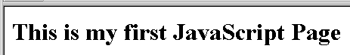

Insert a carriage return in the middle of the statement so that it runs onto two lines, like this: -
document.write('<h1>This is my
first JavaScript Page</h1>');
Save the file and reload it in your browser. You should get a blank page - in some browsers you will get an error message as well.

Displaying Message boxes

Add the following line to your Javascript code: -
document.write('<h1>This is my first JavaScript Page</h1>');
window.alert('Hello World!');
Save the file and reload it in your browser. The following message box should appear: -

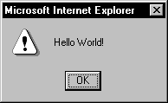
This is useful if you need to display a warning message to the user. This type of box is known as an alert box. There are other boxes available in Javascript too. To get a Window box change the line (a Window box can accept input from users):
window.alert('Hello World!');
to read:
window.prompt('Enter your name:','');
Save and reload. This type of message box can get input from the user:
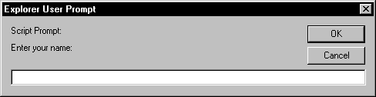

window.alert('Hello World!');

to read:

window.prompt('Enter your name:','');

Save and reload.

Notice the second set of quotes in the command statement. This can contain some default text to save the user having to type it. Change the line to read:

window.prompt('Enter your name:','myname');

Save and reload. Notice the effect this has.
Delete the line.
window.prompt('Enter your name:','myname');

Now replace it with the following:
document.write('<center>well done<br><h1>');
document.write(window.prompt('enter your name:',''));
document.write('</center></h1>');

Save and reload the page. Fill in the prompt box.
You should see your name displayed on the page as follows:

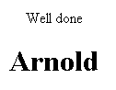

Change the file so that the final output looks like this:
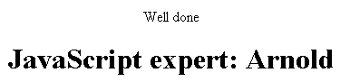

Using Javascript with HTML Forms

Create a new HTML file using the following code: -

<!DOCTYPE html>
<html>
<head><title>Entry form</title>
<meta charset="UTF-8">
</head>
<body>
<form id = "entry1">
<p>
Enter your first name: <input type="text" id="yourname">
</p>
<input type="button" value="Enter" />
</form>
</body>
</html>
View this in your browser.
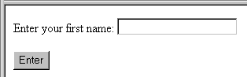
If you push the button nothing will happen, as there is no processing code.
Javascript is often used to process the output of forms.
Now change the line
<input type = "button" value = "Enter" />
to read:
<input type="button" value="Enter" onclick = "window.alert('Hello');" />
Take care with the single and double quotes!
onclick is JavaScript syntax for saying "When the user clicks the button, do something." This is called an event handler.
Save the file and reload it in your browser.
Now push the button: you should see an alert box:
Note the use of quotes that enclose the statement.
window.alert('Hello');
from above.

Change the line:
<input type="button" value="Enter" onClick = "window.alert('Hello');" />
to read:
<input type="button" value="Enter" onclick = "window.alert(document.getElementById('yourname').value);" />
Save and reload. Type your name in the box and press the Enter button. You should see your name in the alert box.

Using Javascript to manipulate form data
Each element in an HTML form can be referred to by its id. The id of the HTML form field in this case is yourname.
So the contents of the yourname field can be referred to as:
document.getElementById('yourname').value
i.e. the value (whatever the user has typed) of the text box called yourname in the form called entry1 in the current document.
You can change the contents of the text box e.g. to greet the user by name:
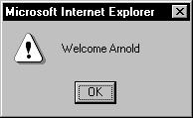

To add two pieces of text together in JavaScript, you use a + sign. This is called concatenation.
<input type = "button" value = "Enter" onclick = "window.alert('Welcome ' + document.getElementById('yourname').value);" />
Make the changes shown in bold above to the file. Save and test your file.
Change the alert box so that it also includes the user's surname. So that when you click the button the text box it should read:
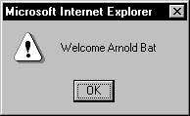

The answer is set out below – try to work it out yourself before looking at the answer.

<!DOCTYPE html>
<html>
<head><title>Entryform</title>
<meta charset="UTF-8">
</head>
<body>
<form name = "entry1">
<p>
Enter your first name: <input type="text" id="yourname">
</p>
<p>Enter your surname: <input type="text" id="surname"></p>
<input type="button" value="Enter"
onclick = "window.alert('Welcome ' + document.getElementById('yourname').value + ' ' + document.getElementById('surname').value);" />
</form>
</body>
</html>
Make the required changes to the file, save and test.

Using Javascript to create pop up windows
Type the following:

<!DOCTYPE html>
<html>
<head><title>Pop-up Content</title>
<meta charset="UTF-8">
</head>
<body>
<h1>COM4006M</h1>
</body>
</html>
Save this as popup_window.html
Now create the following file:

<!DOCTYPE html>
<html>
<head><title>Pop-up Launcher</title>
<meta charset="UTF-8">
</head>
<body>
<form>
<input type="button" value="Pop-up"
onclick = "window.open('popup_window.html');" />
</form>
</body>
</html>

Save this as launcher.html
Open launcher.html file in your browser and press the Pop-up button. You should see a new window open containing the popup_window.html page that you have just written.
Look at the syntax:
onclick = "window.open('popup_window.html');">
i.e. when the button is clicked a new browser window will be opened containing the file popup_window.html
Change the onClick event to read:
onclick = "window.open('http://www.yorksj.ac.uk');">
Save the file and return to your original browser window (you will now have more than one open) and reload. Press Pop-up to open up a new browser window containing the University home page.
In the launcher.html file, change the onClick event to read:
onclick = "window.open('popup_window.html','test', 'status=no,width=300,height=200');">
"test" is a name which has been given to the window so you can refer to it as a TARGET for links (similar to giving form <input> elements a name attribute).
There should not be spaces in-between the new comma separated list i.e.
status=no,width=300
Save and reload. Press Pop-up.
You should see a new smaller window open containing the popup_window.html page that you have just written.
Here are some of the features which you can choose to display:

menubar
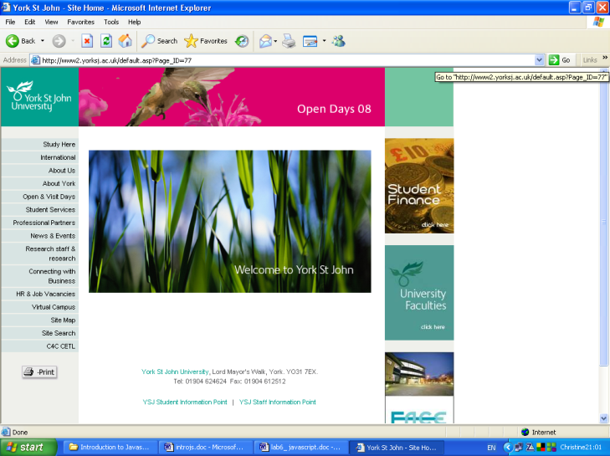
Scrollbars
resizable
location
toolbar
status

Create a new window using the following code:
window.open('popup_window.html','test','status=yes,width=300,height=200');
Again, do not put spaces in-between this list of features.
Open the popup_window.html file and insert the lines:

<!DOCTYPE html>
<html>
<head><title>Pop-up Content</title>
<meta charset="UTF-8">
</head>
<body>
<h1>COM4006M</h1>
<form>
<input type = "button" value = "Close" onClick ="self.close();" />
</form>
</body>
</html>

Save the file.
The amended file should now contain a Close button:
Press the button to check that it closes the new window.

Using Javascript from an external file
Like CSS Javascript can be inline, in the head as a script or as an external file. To place javascript in an external file, write your Javascript as a .js file and then use the following code in the head:
<script src="filename.js" type="text/javascript"></script> or
<script src="filename.js" type="text/javascript" charset="utf-8"></script>

Now convert your examples to use external javascript files.

Lab 4 - Part 2: Javascript and the DOM

Javascript – Objects, Events and Functions

The objects in Javascript are based on the structure of an HTML page and are set out in a hierarchy, with smaller objects contained within larger ones. The hierarchy is set out below.

A window has frames (although frames are optional), then a document. A document may contain forms, which holds elements such as text inputs and buttons. A document may also hold images, targets and other elements.

Other objects that are part of a window on the same level as a document are location and history.

Object | Properties | Methods | Event Handler
window | defaultStatus, status,  window, frames | alert, close, confirm, open, prompt, set-Timeout | onLoad, onUnload
location | hostname, href, pathname, protocol
history | length | back, forward, go
document | alinkColor, bgColor, fgColor, forms, lastModified, links, location, title | clear, close, open, write

The Document object
Objects allow you to manipulate parts of the current document. The biggest object is the document itself. The document object has sub-objects. The two most common are: -

Object | Properties | Methods | Event handler
link | target |  | onClick, onMouseOver
form | action, method, name, target | submit | onSubmit

Form Object
The form object may also have many sub-objects, including text fields, text areas and checkbox, submit and reset buttons.
Object | Properties | Methods | Event handler
text fields | defaultValue, name, value | focus, blur, select | onBlur, onChange, onFocus, onSelect
textarea | defaultValue, name, value | focus, blur, select | onBlur, onChange, onFocus, onSelect
checkbox | checked, default-Checked, name, value | click | onClick
radio | checked, default-Checked, length, name, value | click | onClick
button | name, value | click | onClick
submit | name, value | click | onClick
reset | name, value

Using the DOM to access parts of the Page
To access the contents of a form you would use code like this: -
<form id="form1" name = "form1">
<input type="text" id=" textbox1" name= "textbox1" />
<input type="text" id=" textbox2" name="textbox2"/>
<input type="button" value="write stuff to id" name= "button1" id="clickbutton" onclick = writestuffid() />
</form>
<p id = "para1">
</p>
This form has 2 text fields and one button.
You can access the contents of fields in the following way: -
The contents of the first textbox
document.getElementByID("textbox1").value

The contents of the paragraph
document.getElementByID("para1").innerHTML

Events and Event Handlers

One of the most common methods of using Javascript is to use an event handler to invoke a script.

Here is a list of the most common event handlers:

Event handler | User action | Objects it applies to
onBlur | removes focus from a form element | text fields, text areas, selections
onClick | clicks on button or link | buttons, links
onChange | changes value of a form element | text fields, text areas, selections
onFocus | selects element for input (opposite of blur) | text fields, text areas, selections
onLoad | loads a page | documents
onMouseOver | moves mouse over a link | links
onSelect | selects input field | text fields, text areas
onSubmit | submits form | form submit buttons
onUnload | leaves page | documents

Using Functions, variables, properties and methods

Many of the Javascript event handlers require functions to be created to operate. The onMouseOver and OnMouseOut event handlers are examples of this. In addition, many functions work best using variables.

Functions

Javascript functions are just like a function in a Visual Basic or any other program. It is a self-contained block of code that performs a task or calculation. They are normally written just like any other function and placed in the <HEAD> section of the Web Page between the <SCRIPT> and </SCRIPT> tags.

Functions take the following form: -

Function (variable(s) being passed to function)
{
Function statements

Return value from function if there is one
}

Variables

Javascript variables can be assigned and declared at any point in a program or script. Javascript variables can also store any type of data – numbers, strings, Boolean values or null – without having to be specifically typed.

Variables are assigned in the following way: -

X=99
or
var message = “This is a piece of text”

Use var to declare a variable only within a function.

Javascript variables have the following naming rules. Must start with a letter or underscore. They may contain any combination of letters or digits and symbols are not permitted (except for _ and $). Note Javascript variables are CASE SENSITIVE.

Javascript variables can be scoped in two ways.

Variables declared in the <BODY> section are global in scope.
Variables declared within functions are local to that function.

Combining two functions together

Two functions can be run by separating them with a “;”.

For example: -

OnClick=”function1();function2()”

Examples of some basic functions.

Reading from a form field and writing the contents into a paragraph
<!DOCTYPE html>
<html>
<head><title>DOM Example</title>
<meta charset="UTF-8">
<script language="JavaScript">
/* <![CDATA[ */
function writestuff()
{
document.getElementById("id1").innerHTML = document.getElementById("texttowrite").value;
}

/* ]]> */
</script>
</head>

<body>
<p name="class1">
This paragraph has just a class identifier
</p>
<p class="class1" id="id1">
This paragraph has an id and a class identifier
</p>
<form>
<input type="text" id="texttowrite" />
<input type="button" value="write stuff to id" onclick = writestuff() />
</form>
</body>
</html>
Examples

How to use the onmouseover event handler.

This example shows you how to program your web page so that when you move the mouse over a hyperlink, text will be written to and then change in a paragraph on the web page.

onmouseover is an event handler which specifies an action to be carried out when a specific Event occurs. Events are things that happen when a user or the browser does something - e.g. clicks or moves the mouse or loads a page. When the event happens, the JavaScript code following the equals (=) sign executes.
Here are some of the most important events handlers which detect different types of user action:
onmouseout (when the user moves their mouse away from something)
onclick (e.g when a user clicks a button)
onload (when a page is loaded by the browser)
onfocus (happens when an item on a screen is selected)

Example: how to use the onmouseover and onmouseout event handlers to change the contents of the paragraph with id “tohere”.

<html>
<head><title>Mouseover</title>
<meta charset="UTF-8">
<script>
function writetopara(input){
document.getElementById("tohere").innerHTML = input;
}
</script>
</head>
<body>
<p>
<a href="http://www.yorksj.ac.uk/" onMouseover="writetopara('You have moved over the link')" onMouseout="writetopara('You have moved out from the link')"> York St John </a></p>
<p id="tohere"></p>
</body>
</html>
Note the double/single quotation marks!!!

Example: how to associate JavaScript commands with a form button.

<form name="myform">
<input type="button" value="Press me" onclick=" window.status='You clicked a button'; return true;" />
</form>

With every button there is an onclick event handler associated with it.
There is an onfocus event handler associated with the text box.
There is an event handler called onblur which occurs when the focus leaves a screen item - i.e. when the focus moves to a different item.

How to use Javascript to enable image rollovers

To do this you need to use the onmouseover event to change to a different image.

Example:

<!DOCTYPE html>
<html>
<head><title>Rollover</title>
<meta charset="UTF-8">
</head>
<body>
<a href= " http://www.yorksj.ac.uk " onmouseover="flipimage.src='image2.gif'; return true;">
<img src="image1.gif" name="flipimage" border="0" >
</a>
</body>
</html>

To reshow the original image when the mouse moves off the image

<!DOCTYPE html>
<html>
<head><title>Rollover</title>
<meta charset="UTF-8">
</head>
<body>
<a href=" http://www.yorksj.ac.uk " onmouseover="flipimage.src='image2.gif'; return true;"
onmouseout="flipimage.src='image1.gif'; return true;">
<img src="image1.gif" name="flipimage" border="0" >
</a>
</body>
</html>

How to use Javascript to write functions

This example shows how to write a function statement and some user defined code to calculate the circumference of a circle using the formula Circumference=2Πr

Example:

<!DOCTYPE html>
<html>
<head><title>Functions</title>
<meta charset="UTF-8">
<script type="text/javascript">
/* <![CDATA[ */
function calculateCircumference(radius)
{
circumference=2 * Math.PI * radius;
return circumference;
}
/* ]]> */
</script>
</head>
<body>
<form name="myForm">
<input type="button" value="Calculate" onclick="document.myForm.answer.value= calculateCircumference(2.71);" />
<br />
<input type="text" name="answer" />
</form>
</body>
</html>

This function works by clicking on the Calculate button, however, this example will always calculate the circumference for a radius of 2.71.

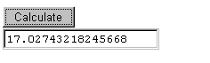

Looking at the code in more detail:
<script type="text/javascript">
/* <![CDATA[ */
function calculateCircumference(radius)
{
circumference=2 * Math.PI * radius;
return circumference;
}
/* ]]> */
</script>

This part is the actual function itself. It has a name that tells you what it does, and it takes one argument (radius).
Notice these lines in the <body> of the page:
<input type="button" value="Calculate"
onclick="document.myForm.answer.value= calculateCircumference(2.71);">
<br />
<input type="text" name="answer" />
The <input> tags are HTML to create the button and the answer box on the screen. Notice the embedded syntax for calling the function, and supplying the value of the argument required:
calculateCircumference(2.71)
Once the function has been called it runs and performs the following calculation:
2 * Math.PI * 2.71
The answer is stored as something called circumference (a variable).
This is done in this line: -
onclick="document.myForm.answer.value= calculateCircumference(2.71)
When the function is called the onclick instructions also specify what to do with the answer.

This line: -

<input type="text" name="answer" />

outputs the calculated value to the screen.

Note that in this example the value of radius has been hard-coded into the script.

Using Javascript to Validate values

This example shows how to use FORM elements and a validation function associated with the submit event.

Example:

<!DOCTYPE html>
<html>
<head><title>Validation</title>
<meta charset="UTF-8">
<script type="text/javascript">
/* <![CDATA[ */
function validate()
{
if(document.myForm.surname.value == "")
{
window.alert('You must enter your surname');
return;
}
document.myForm.submit();
}
/* ]]> */
</script>
</head>
<body>
<h1>Booking Form</h1>
<form name="myForm">
<p>Enter your First Name:
<input type="text" name="firstname" /></p>
<p>Enter your Surname:
<input type="text" name="surname" /></p>
<p><input type="button" value="Send details:"
onclick="validate()" /></p>
</form>
</body>
</html>

This code works so that the button can be pressed with and without entering a surname. The validation checks that the user has entered a surname. If the box is empty, it will display an alert message.
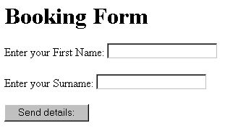

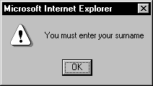

These lines inside the function check the contents of the surname form element. If it is empty when the function runs (i.e. it has a value of "") then the alert box is triggered: -
if(document.myForm.surname.value == "")
{
window.alert('You must enter your surname');
return;

This code will send the form data information to its final destination (e.g. a php script on another page) - but ONLY if the validation test has been passed. In this example the form submits to itself (there is no action specified in the form tag) which essentially reloads the page: -

document.myForm.submit();

Exercises

- Create a page with a hyperlink in it and code the link so that it shows a message in an alert box, when your mouse passes over it.
- Create a form and add a prompt box that appears when you click a button.
- If you do not have a text box in this form add one. Then use the onFocus event handler to show a message in an alert box.
- Create another text box and use an onblur event handler to display an alert box message when the user clicks in a new box (i.e. they Blur the first box).
- Find two images from the web and update one of your hyperlinks to use an image. Then create a rollover on the hyperlink that displays an image when the mouse is over it and displays the original image when the mouse moves away from it.
- Update another link to that the hyperlink displays a message in the status bar at the bottom of the screen showing what will be the result of clicking on the link.
- Update a button so that the button displays a message a div that is somewhere on the same page.
- Add the calculate circumference form to one of your web pages or create a new one. Update the code so that it will calculate the circumference of a value that you enter rather than the hard coded value of 2.71 shown in the example.
- Add to this a personalised greeting message for the visitor when they have pressed the submit button.
- Use the form validation code shown above on one of your pages. Update it to validate the surname box.

Advanced Tasks

- Use Javascript to enable form validation of email addresses. The examples in part 1 of the lab just validate by checking whether a field is empty. For this exercise find out how to check if an email address is a valid email address i.e. if it has an @ contained in it
- Use Javascript to change the colours of a page (this is often done to enable better accessibility), i.e. change the background and text colour combinations
- Use Javascript to enable users to increase or decrease the font size of the text within the page.

I would strongly advise you to be able to do these tasks in Javascript as you will come across this type of functionality time and time again.

